Test Script:

class GuidepageSimulation extends Simulation {

val httpConf = httpConfig
.baseURL("http://testsite/")
.proxy("IP ADDRESS",80)
.acceptHeader("*/*")
.acceptEncodingHeader("gzip, deflate")
.acceptLanguageHeader("en-gb,en;q=0.5")
.connection("keep-alive")
.userAgentHeader("Mozilla/5.0 (Macintosh; Intel Mac OS X 10.9; rv:30.0) Gecko/20100101 Firefox/30.0")

val headers_1 = Map("Accept" -> """text/html,application/xhtml+xml,application/xml;q=0.9,*/*;q=0.8"""
)

val headers_2 = Map("Accept" -> """text/css,*/*;q=0.1""")

val headers_11 = Map(
"Accept" -> """image/png,image/*;q=0.8,*/*;q=0.5"""
)

val headers_51 = Map(
"X-Requested-With" -> """XMLHttpRequest"""
)

val headers_64 = Map(
"Accept" -> """application/json, text/javascript, */*; q=0.01""",
"X-Requested-With" -> """XMLHttpRequest"""
)

val scn = scenario("Scenario Name")

.group("Home Page") {

exec(http("Homepage")
.get("/")
.headers(headers_1)
)

.exec(http("request_2")
.get("/scripts/vendor/tags/jquery.tagsinput.css")
.headers(headers_2)
)
.exec(http("request_3")
.get("/assets/styles/plugins.css")
.headers(headers_2)
)
.exec(http("request_4")
.get("/scripts/vendor/datepicker/css/datepicker.css")
.headers(headers_2)
)
.exec(http("request_5")
.get("/assets/styles/screen.css")
.headers(headers_2)
)
.exec(http("request_6")
.get("/styles/jquery-ui-1.10.4.custom.min.css")
.headers(headers_2)
)
.exec(http("request_7")
.get("/styles/mock.css")
.headers(headers_2)
)
.exec(http("request_8")
.get("/bower_components/modernizr/modernizr.js")
)

.exec(http("request_9")
.get("/assets/styles/bootstrap.css")
.headers(headers_2)
)

.exec(http("request_10")
.get("/scripts/require.js")
)

.exec(http("request_11")
.get("/assets/images/mytest-logo-sm-sq_small.png")
.headers(headers_11)
)
.exec(http("request_12")
.get("/assets/images/testuk-crest-text.png")
.headers(headers_11)
)
.exec(http("request_13")
.get("/images/mytestalpha_small.png")
.headers(headers_11)
)
.exec(http("request_14")
.get("/assets/images/btn-chevron-right.png")
.headers(headers_11)
)
.exec(http("request_15")
.get("/assets/images/search.png")
.headers(headers_11)
)
.exec(http("request_16")
.get("/assets/fonts/fira/FiraSans-Regular.woff")
.headers(headers_1)
)
.exec(http("request_17")
.get("/assets/fonts/glyphicons-halflings-regular.woff")
.headers(headers_1)
)

.exec(http("request_18")
.get("/scripts/main.js")
)
.exec(http("request_19")
.get("/assets/fonts/fira/FiraSans-Medium.woff")
.headers(headers_1)
)

.exec(http("request_20")
.get("/scripts/app/app.js")
)
.exec(http("request_21")
.get("/scripts/vendor/when/when.js")
)
.exec(http("request_22")
.get("/scripts/vendor/showdown.js")
)

.exec(http("request_23")
.get("/scripts/vendor/jquery.js")
)
.exec(http("request_24")
.get("/scripts/app/templates.js")
)
.exec(http("request_25")
.get("/scripts/aquilla/edit.js")
)
.exec(http("request_26")
.get("/scripts/vendor/jquery.blockUI.js")
)
.exec(http("request_27")
.get("/scripts/app/search.js")
)
.exec(http("request_28")
.get("/scripts/vendor/jstree/jstree.js")
)
.exec(http("request_29")
.get("/scripts/app/notification.js")
)
.exec(http("request_30")
.get("/scripts/app/cookie.js")
)
.exec(http("request_31")
.get("/scripts/app/filter.js")
)

.exec(http("request_32")
.get("/scripts/app/menu.js")
)
.exec(http("request_33")
.get("/scripts/vendor/moment.js")
)

.exec(http("request_34")
.get("/scripts/app/guide.js")
)
.exec(http("request_35")
.get("/scripts/vendor/ICanHaz.min.js")
)

.exec(http("request_36")
.get("/scripts/vendor/jquery.ba-hashchange.js")
)
.exec(http("request_37")
.get("/scripts/app/utility.js")
)
.exec(http("request_38")
.get("/scripts/aquilla/tequilla.js")
)
.exec(http("request_39")
.get("/scripts/vendor/jquery.scrollTo.min.js")
)
.exec(http("request_40")
.get("/scripts/app/slugify.js")
)

.exec(http("request_41")
.get("/scripts/aquilla/ContentNode.js")
)
.exec(http("request_42")
.get("/scripts/aquilla/ContentNodeInterface.js")
)
.exec(http("request_43")
.get("/scripts/vendor/knockout-3.1.0.js")
)
.exec(http("request_44")
.get("/scripts/aquilla/ContentTree.js")
)
.exec(http("request_45")
.get("/scripts/aquilla/sort.js")
)
.exec(http("request_46")
.get("/scripts/vendor/jquery.delayed-1.1.0.min.js")
)
.exec(http("request_47")
.get("/scripts/vendor/debounce.js")
)
.exec(http("request_48")
.get("/scripts/vendor/datepicker/js/bootstrap-datepicker.js")
)
.exec(http("request_49")
.get("/scripts/vendor/slidebars/slidebars.js")
)

.exec(http("request_50")
.get("/scripts/vendor/tags/jquery.tagsinput.min.js")
)
.exec(http("request_51")
.get("/client-templates/templates.html")
.headers(headers_51)
)
.exec(http("request_52")
.get("/scripts/vendor/jquery-ui-1.10.4.custom.js")
)

.exec(http("request_53")
.get("/scripts/vendor/domReady.js")
)

.exec(http("request_54")
.get("/scripts/vendor/jstree/css/style.min.css")
.headers(headers_2)
)
.exec(http("request_55")
.get("/scripts/app/autorun.js")
)

.exec(http("request_56")
.get("/scripts/app/councilservicelookup.js")
)
.exec(http("request_57")
.get("/scripts/vendor/jquery.matchHeight-min.js")
)

}

//Category List Page
.pause(1)
.exec(http("request_58")
.get("/housing/")
.headers(headers_1)
)
.pause(22 milliseconds)
.exec(http("request_59")
.get("/assets/fonts/fira/FiraSans-Light.woff")
.headers(headers_1)
)
//Content Item List
.pause(1)
.exec(http("request_60")
.get("/housing/council-housing/")
.headers(headers_1)
)
.pause(1)
.exec(http("request_61")
.get("/maintenance-and-repair-of-council-housing/")
.headers(headers_1)
)
.pause(72 milliseconds)
.exec(http("request_62")
.get("/assets/images/Icon_External_Link.png")
.headers(headers_11)
)
.exec(http("request_63")
.get("/assets/images/btn-chevron-left.png")
.headers(headers_11)
)
.pause(20 milliseconds)
.exec(http("request_64")
.get("/service/related/maintenance-and-repair-of-council-housing")
.headers(headers_64)
)

setUp(scn.users(1).protocolConfig(httpConf))
}

Home Page load Time : 5872 ms (both min, max,mean, 95th, 99th)

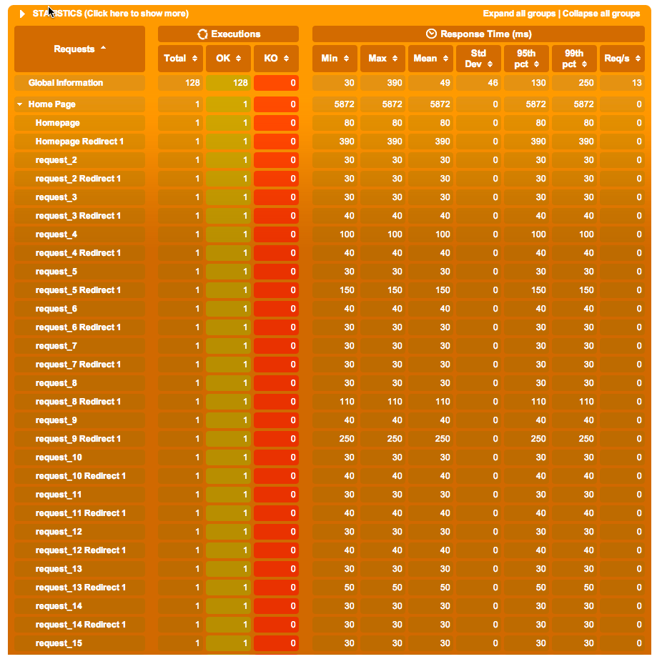

Chrome:

Browser seems triggering few static resource requests in parallel. Kindly advise if there is way to simulate the same using Gatling too.

